Description of the Subject for the Fan Website

The subject of the fan page is the all-new Ford Mustang, codenamed “s650”. This new Mustang is based on the current generation Mustang (codename "s550") and shares a lot of its internal. But the new s650 has many visual changes (exterior and interior), new features, and better performance compared to the current generations. The new Mustang continues to have an optional V8 and an optional manual transmission. While other vehicles in its category are being discontinued in 2023 and 2024. Ford is still sticking with the gasoline engines, while also having a 4-cylinder version for those who do not care about the performance of the vehicle and want to have better MPG.

When I was growing up, I watched a lot of movies and TV shows like NFS, Fast and Furious, Cars (by Disney), West Coast Customs, etc. When the current generation of mustangs came out in 2014, I started liking how the vehicles looked like. The movies and TV shows I watched inspired me to get my Mustang which is the current generation Mustang. I like what Ford has done to the current Mustang and what they want to do in the future for the next generation of Mustangs. Mustangs have been competitive with a lot of vehicles in different categories with different price points. This is the reason why I believe it's been a popular vehicle for many years.

The primary purpose of the home page is to showcase the most exciting new features of the vehicle. The images will reflect the elements chosen for the home page and be a visual hook to attract visitors to the website. Depending on how the website comes out, the home page might have links to other websites to direct the visitors to the places the text is talking about.

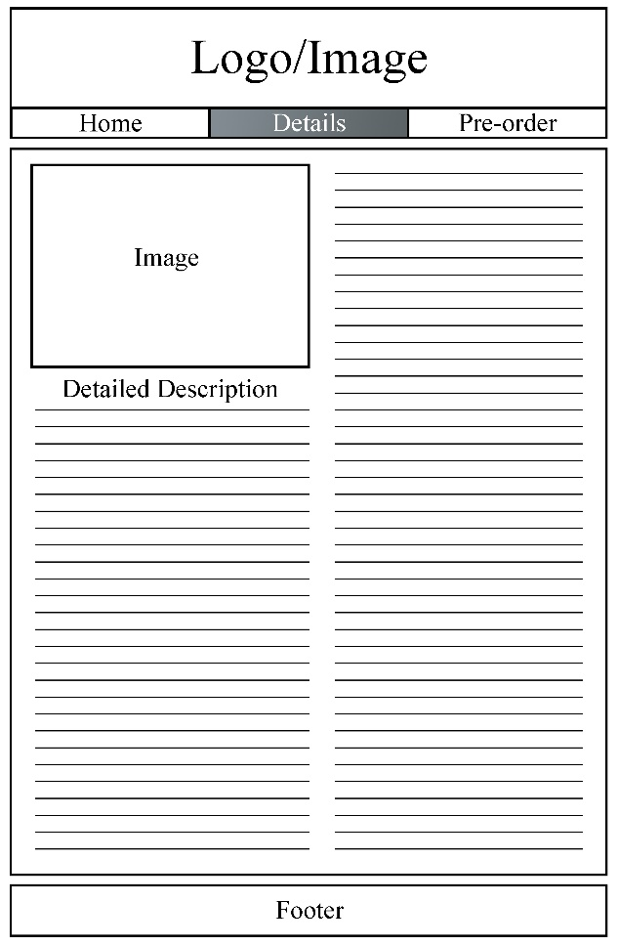

The details page will be talking about all the new features that the vehicle will come with when it comes out, the specifications of the engine, body, weight, and more, when the car is available to the public for purchase, etc. The details page will have links to other hidden pages or different websites that will not be in the navigation menu.

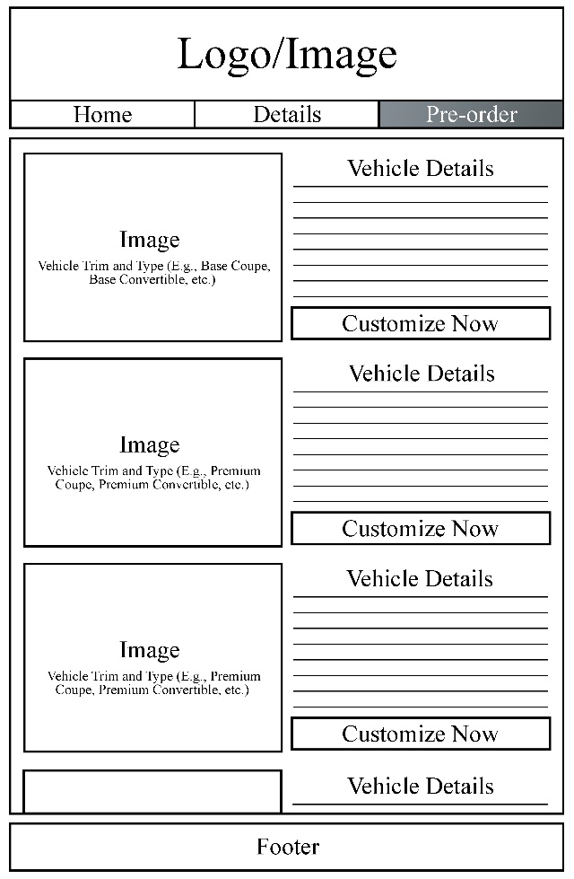

The pre-order page will allow the visitors to look at the different trims and types of vehicles (E.g., base coupe, base convertible, premium coupe, premium convertible, etc). There will be an image and a short paragraph giving details about the vehicle next to the image. Under the short paragraph, there will be a button that will take them to a different page that will allow them to enter their information. There will be different images showing the different trims and vehicle types.

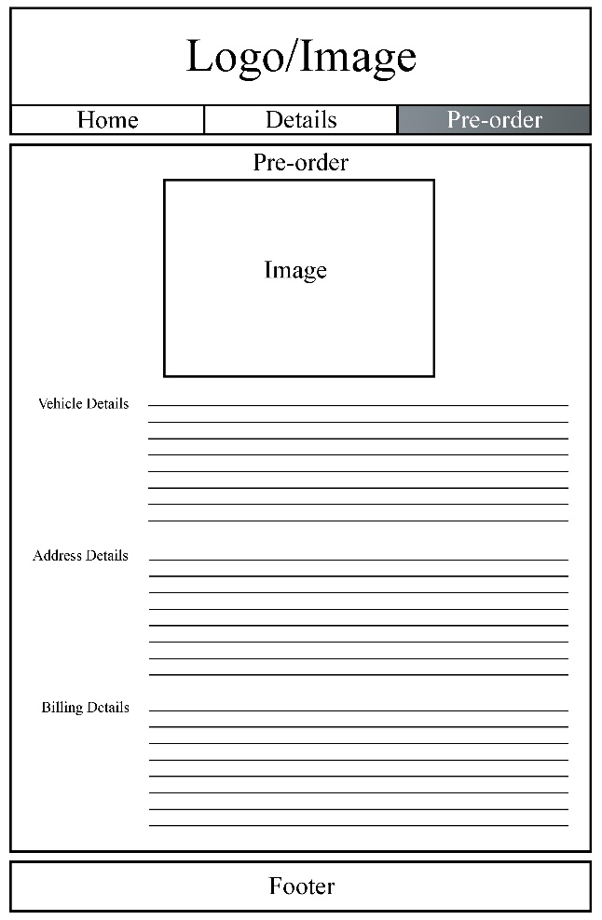

This page is the fill-out form page that will appear after the visitor clicks on the “Customize Now” button. This page will have the image of the trim they picked, and they can change the details of the vehicle in the “Vehicle Details” part. This includes the color of the car, the engine type, features, etc.